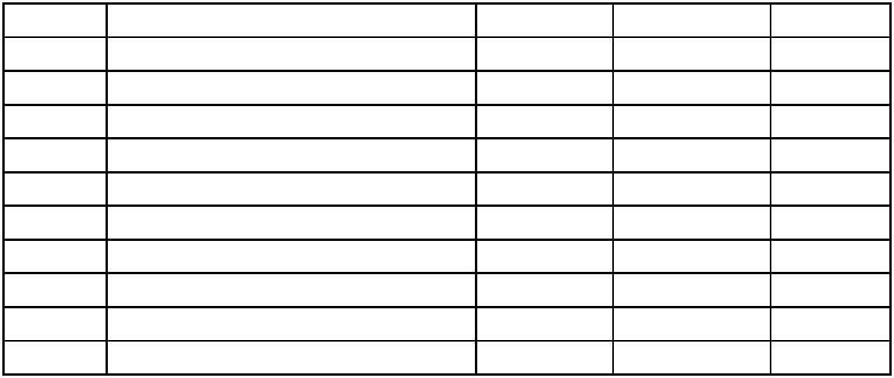  Ranking | Tussenstand teams na S2 2023 | Punten S1 | Punten S2 | Totaal
1 | Hának Competition Pro Team | 22 | 21 1/2 | 43 1/2
2 | A&M Flyfishing 1 | 17 | 49 | 66
3 | De Buzzer | 30 | 41 1/2 | 71 1/2
4 | Fly Only | 57 | 50 | 107
5 | Fly Fishing Crusaders | 41 | 85 | 126
6 | Handy Fish | 68 | 63 | 131
7 | A&M Flyfishing 2 | 62 | 74 1/2 | 136 1/2
8 | Poseidon Pro Team | 82 | 74 1/2 | 156 1/2
9 | Team Zuid-Nederland | 102 | 56 1/2 | 158 1/2

